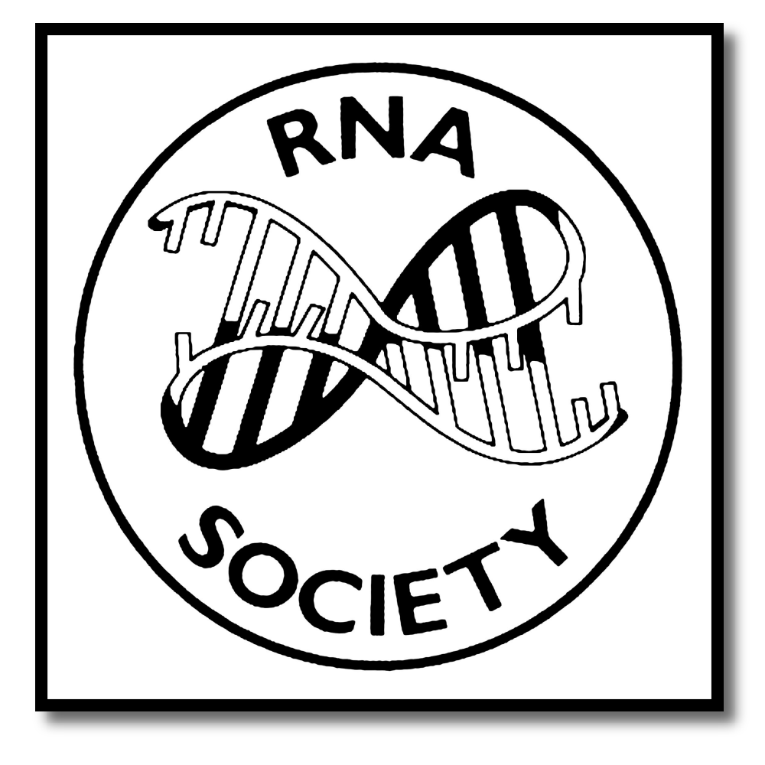
The RNA Society/Scaringe
Young Scientist Award

H. Letter of support
Please ask your PI or another PI familiar with your work to provide this letter of support for your application to RNA Society/Scaringe Award.

- The PI should complete this form using Microsoft Word by typing your text into the gray boxes; the boxes will expand as you write.

- Name the completed form as LastName of Applicant_ScaringeRef.doc

Upload the application here: https://www2.rnasociety.org/scaringe-award-recommendation/

- DUE DATE: October 1, 2020
---------------------------------------------------------------------------------------------------------------------
Name of Applicant
PI name
PI institution
Phone of PI
Email of PI

PI Recommendation (4000 words maximum; longer text will be truncated)

